**ITRODUCTION TO MOTHERBOARD**

**Non-integrated Motherboard:**

Mostly, traditional motherboard were designed as non- integration. These **types of motherboard** were not support directly of various connectors such as **I/O port connectors**, hard drive connectors, CD drive connectors, and more. Use the expansion board for connecting those connectors on those **types of motherboards**, so its case has more space for using the external expansion cards. If any components gets defect then they can be repair and maintain with low cost.

**Integrated Motherboard:**

Today, all motherboards are designed as integration. These **types of motherboard** no need external expansion card because all **ports and connectors** such as Serial and parallel ports, IDE, CD drive , and more are embedded on the motherboard but its repair and maintenance  is costly to non integration motherboard. There are some features like as well accessibility, fast speed, and cost effective along with their rich features.

**Motherboard Form Factors**

In **Motherboard form factor**, measure various factors such as logical design, size, its components, and power supply connectors placement in the motherboard.

**Types of Motherboard according to Motherboard form factors**

* **AT Motherboard**
* **Baby AT Motherboard**
* **XT Motherboard**
* **Fully ATX Motherboard**
* **Micro-ATX Motherboard**
* **Flex-ATX**
* **LPX Motherboard**
* **BTX Motherboard**
* **Pico BTX Motherboard**
* **Mini ITX Motherboard**
* **E-ATX Motherboard**

**AT Motherboard:**

AT stands for “Advance Technology”.  **AT Motherboard** was tradition motherboard that was introduced by IBM Company in 80s. Those **types of motherboards** were size (dimensions (13.8 x 12 inch)) and shape approximate double to other using motherboards. Due to their big size, they were not able to use in small size desktop computers because in which was used 386 processors, and had big challenging task if to be install, service and upgrade in the [**computer**](https://digitalthinkerhelp.com/how-many-types-of-computer-and-their-functions/) due to their complicated layout.

Examples are **P-III Processors**

**Features are:**

* SD RAM slots
* PGA sockets
* 20 pin connectors
* PCI and ISA expansion slots
* Serial mouse connector
* Keyboard connector

**Baby AT Motherboard:**

**Baby AT Motherboards** was developed by IBM in 1987 while decreasing the dimension to last **AT motherboard**

**Baby AT motherboard** has to combine both features of AT and XT motherboard. **Baby AT motherboard** required small space compare to **AT motherboard**. Due to small size, their installation and service were performed very easy.

**Baby AT motherboard** was getting more demands in growing computer hardware industry. **Baby AT Motherboard** had only one keyboard connector which was known as DIN, but if users want to connect more devices to motherboard then in which had expansion slot, and with using that could be connected more needed card while getting their extra benefits and functionalities.

Examples are **Pentium-III and Pentium-IV**

**Features are:**

* SD and DDR RAM slots
* PGA processor sockets
* 12 and 20 pin connectors
* PCI and ISA expansion slots
* DIN port (big keyboard)
* Serial mouse port

**XT Motherboard:**

XT full name is “**Extended Technology**“. **XT motherboard** was developed by IBM in 1983. **In XT motherboard,** use traditional Logic Board.

**Features are:**

* 12 pins connectors
* RAM expansion slots ISA (Industry Standard Architecture)
* DIMM slots
* Processor along with LIF(Low Insertion force)

Instead of them, if you want to use other port then you have to go market for buying Add-ON card, and insert it on the **XT motherboard**. Now you are able to avail extra functionalities of **XT motherboard**.

**Fully ATX Motherboard:**

**ATX** stands for “**Advanced technology extended**“. Due to some problems in **AT motherboard**, Intel Corporation was decided for developing the fully **ATX motherboard** along with extra functionalities to AT motherboard. Fully **ATX motherboard** occupies low space compares to AT motherboard as well as has options to interchange of their connected parts.

**Examples are** – Pentium-IV, Dual Core, Core 2 Duo, Core 2 Quad, Quad Core, i3, i5 and i7 Processors

**Feature included:**

* DIMM slots
* MPGA CPU socket
* 12 and 20 pin connectors
* SATA and IDE connectors
* PCI, ISA, and AGP expansion slots
* Micro ATX Motherboards

**Micro-ATX Motherboard:**

**Micro ATX motherboard** is small size compare to **ATX motherboard**, and its dimension is 9.6 x 9.6 inch. Micro ATX motherboard contains only maximum of four Express expansion slots as well as these types of motherboard is cost effective to **ATX motherboard**.

**Flex-ATX:**

Flex-ATX mother board is family member of Micro ATX motherboard and it was introduce by Intel in 2000. Flex-ATX was small size so it mostly used for personal computer, but in which use latest technology. This motherboard had low cost but no more famous in computer industry.

**LPX Motherboard:**

LPX stands for “**Low Profile extension**“, and **LPX motherboard** was invented by Western Digital in 1987. **LPX motherboard** use the riser card, and riser card contains various slots for video, parallel, serial, and PS/2 ports as well as LPX motherboard is made with 9″ wide and 13″ deep dimension. User can use more extra functionalities while connecting extension cards with parallel to motherboard, and **LPX motherboard** occupies very low space due to his slimmer size.

**BTX Motherboard:**

“**Balanced Technology extended**” is full name of **BTX**.  **BTX motherboard** was developed by Intel in 2003 along with short out all problems over the ATX motherboard. **BTX motherboard** work as a low profile features, and supportable to various dimensional motherboards as well as more verities of motherboard components. But due to some problems, Intel was decided for stopping this **BTX motherboard** in 2006.

**Advantages are:**

* Low power consumption
* Produce very low heat
* Support to well cooling capabilities
* Reduce the latency between both Northbridge and Southbridge
* Well logical design for rear side Input/output controller

**Pico BTX Motherboard:**

**Pico BTX motherboard** is smaller like as “micro” in size, so it is known as “Pico”. **Pico** **BTX motherboard** can support to one or two extension slots.

**Mini ITX Motherboard:**

**Mini ITX motherboard** was developed by VIA in 2001 with slimmer compare to other using traditional motherboard. **Mini ITX motherboard** is not getting more heat due to their less power consumption layout design. These motherboards have more beneficial for home theater because it reduces the fan noise, and enhance the picture quality. **Mini ITX motherboard** has only one expansion slot along with 33 MHz 5V 32-bit PCI slot.

**E-ATX Motherboard:**

**E-ATX** is also called with full name “**extended ATX Motherboard**“. **E-ATX motherboard** is large in size but its large sizes not its disadvantage because these types of motherboard use for mainly playing games.

**Benefits are:**

* Contain more PCI and DIMM slots.
* Some extra features such as Wi-Fi and sound cards are embedded in the motherboard.
* Can be support maximum of 128 GB RAM.
* Use various core CPU.
* In built features are over clocking, USB 3.0, and USB 3.1.

# Computer Motherboard and Its Components

The **computer motherboard** connects all the parts(components) of a computer together.  
Mainboard, baseboard, mobo (abbreviation), system board,  MB (abbreviation), logic board are the synonyms of computer’s motherboard .  
The motherboard is the most important component in the PC. All the component such as RAM stick, hard disk drive, optical drives, processor, processor fan and external card are plugin into motherboard.  
***Computer motherboard*** is single platform to connect all of the parts (components) of a computer together,Hence it considered as the backbone of a computer.

**Some of popular manufacturers of the motherboard.**  
**Intel**  
**ASUS**  
**AOpen**  
**ABIT**  
**Biostar**  
**Gigabyte**  
**MSI**

The motherboard may be characterized by the

### i) form factor ii) chipset iii) type of processor socket used

**i) Form factor** refers to the motherboard’s geometry, dimensions, arrangement and electrical  
requirements. Advanced Technology Extended (ATX) is the most common design of motherboard for desktop computers.

**ii) Chipset** is a circuit, which is used to controls the of resources such as the bus interface with the processor, cache memory and RAM, expansion  
cards, etc. It used to coordinate data transfers between the various components of the computer.

**iii) The processor socket** is a connector into which the processor is mounted. The Basic Input Output System (BIOS) and Complementary Metal-Oxide Semiconductor (CMOS) are present on the motherboard.

# Components of Motherboard

The important components of a Motherboard are given below:

[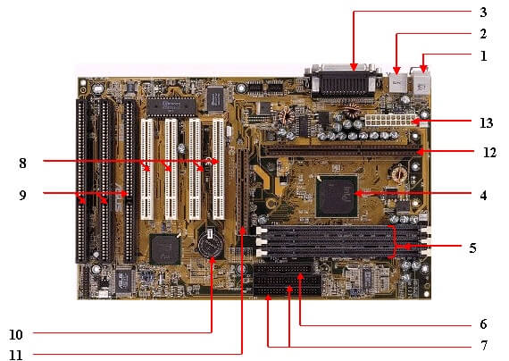](https://www.kencorner.com/wp-content/uploads/2018/03/Kencorner_Mother_Board1.jpg)

**1. Mouse & keyboard :**  
There are two types of keyboard and mouse  connectors.First type is called PS/2 and second one is called USB.

[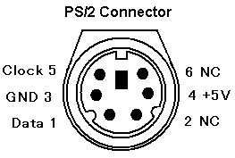](https://www.kencorner.com/wp-content/uploads/2018/03/Kencorner_ps2Connector.jpg)

**2. USB (Universal serial bus) :**  
USB is **Universal serial bus.** It is used for connection for PC. There are  different devices which is used to connect with USB port such as mouse, keyboards, scanners, cameras, and even printers.USB connector is used to connect computer motherboard and a peripheral device. You can insert or remove peripheral device connect by USB connector without restarting your system.

**3. Parallel port  :**  
Most of old  printers are used to connect by  parallel port. Parallel port used more than one wire for sending or receiving multiple bits of data at once, while serial port uses only one wire. Parallel ports use a 25-pin female DB connector.

**4. CPU Chip  :**  
CPU refers to a processor, the central processing unit, also called the microprocessor performs all the task that take place inside a computer system.It is also know as brain of computer.

**5. RAM slots :**  
RAM slots is for attaching RAM on it in general desktop we can see two slot of RAM but in server motherboard we can see 4+ slot of RAM.RAM comes in different size(memory).

**6. Floppy controller :**  
In old motherboard the floppy drive connects to the computer via a 34-pin ribbon cable, one end of ribbon cable is connect to floppy drive and other is connected to the motherboard.

**7. IDE controller :**  
IDE that is **Integrated Drive Electronics**,also called as **ATA** or Parallel **ATA (PATA)**.IDE controller is responsible for controlling the hard drive. Today’s computers no longer come with a IDE controller.

**8. PCI slot :**  
PCI stands for Peripheral Component Interface, PCI slot allows you to insert expansion cards into your computer. PCI used to connect additional PCI device like network cards, sound cards,modems,video cards.Some of today’s computers no longer come with a PCI expansion slot.Its connect audio, video and graphics.

**9. ISA slot :**  
ISA stands for Industry Standard Architecture, It is the standard architecture of the Expansion bus.Its connect modem and input devices.

**10. CMOS Battery :**  
CMOS is complementary metal-oxide-semiconductor is used to store BIOS setting in computer motherboard. CMOS Battery also store date and time.

**11. AGP slot :**  
The Accelerated Graphics Port (AGP) is a high-speed point-to-point channel for attaching a video card to a computer system, If you have a modern motherboard, you will almost certainly notice a single connector that looks like a PCI slot.A fast port for a graphics card

**12. CPU slot :**  
The processor socket (also called a CPU socket) is the connector on the motherboard that connect a CPU.

**13. Power supply plug in :**  
The Power supply provides the necessary electrical power to make the computer system operate. The power supply takes standard 110-V AC power and converts into  +/-12-Volt, +/-5-Volt, and 3.3-Volt DC power.  
The power supply connector has 20-pins, and the connector can go in only one direction.

[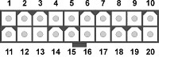](https://www.kencorner.com/wp-content/uploads/2018/03/Kencorner_Power_Connector.jpg)

# Connector Side of Motherboard

[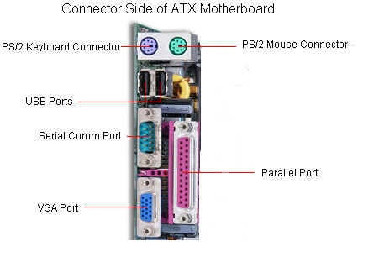](https://www.kencorner.com/wp-content/uploads/2018/03/Kencorner_Connector_Motherboard.jpg)

|  |  |
| --- | --- |
| [component of motherboard Keyboard port](https://www.kencorner.com/wp-content/uploads/2018/03/Keyboard.jpg) | **Keyboard & Mouse :** This Port is used to connect keyboard and mouse , now a day we use USB connector for keyboard and mouse |
| [component of motherboard serial port](https://www.kencorner.com/wp-content/uploads/2018/03/serialport.jpg) | **Serial or COM :**  It used to connect some types of modem, scanner, or digital camera |
| [component of motherboard parallel Port](https://www.kencorner.com/wp-content/uploads/2018/03/parallelPort.jpg) | **Parallel or Printer** : You plug your printer into the parallel, or printer, port. But now printers may use a USB port |
| [component of motherboard USB port](https://www.kencorner.com/wp-content/uploads/2018/03/USBport.jpg) | **USB :** Designed to replace older Serial and Parallel ports, the USB (Universal Serial Bus) can connect computers with a number of devices, such as printers, keyboards, mice, scanners, digital cameras, PDAs, and more |
| [component of motherboard monitor Port](https://www.kencorner.com/wp-content/uploads/2018/03/monitorPort.jpg) | **Video or Monitor** : It used to connect your monitor into the video port |
| [component of motherboard Line Out](https://www.kencorner.com/wp-content/uploads/2018/03/LineOut.jpg) | **Line Out** : It used to connect speakers or headphone into the Line Out jack |
| [component of motherboard line IN](https://www.kencorner.com/wp-content/uploads/2018/03/lineIN.jpg) | **Line In** : The Line In jack allows you to listen to your computer using a stereo system |
| [component of motherboard microphone port](https://www.kencorner.com/wp-content/uploads/2018/03/microPhonePort.jpg) | **Microphone** : It used to connect a microphone into this jack to record sounds on your computer |
| [component of motherboard JoyStick](https://www.kencorner.com/wp-content/uploads/2018/03/JoyStick.jpg) | **Joystick or Game** : If you have a joystick, musical (MIDI) keyboard, or other gaming device, this is where you plug it in |
| [component of motherboard Phone or Modem port](https://www.kencorner.com/wp-content/uploads/2018/03/PhoneORModem.jpg) | **Phone or Modem** : The phone or modem jack is where you plug your computer into a phone line |
| [component of motherboard LAN port](https://www.kencorner.com/wp-content/uploads/2018/03/LANport.jpg) | **Network or Ethernet** : You can connect your computer to a network by plugging in an Ethernet cable in this port |
| [component of motherboard Printer Port](https://www.kencorner.com/wp-content/uploads/2018/03/PrinterPort.jpg) | **SCSI** : It used to connect a hard drive, CD-ROM drive, or other device to a computer |

# Below Diagram show component of motherboard

Here we are using Asus H110M-cs motherboard

[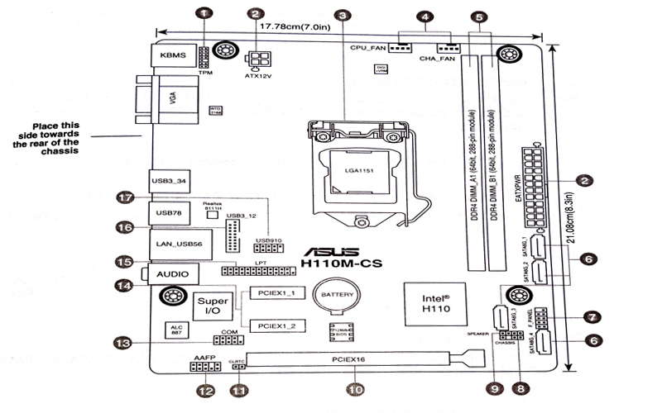](https://www.kencorner.com/wp-content/uploads/2018/03/Part-of-motherBoard.jpg)

**(1)  TPM connector (14-1 pin TPM)**

[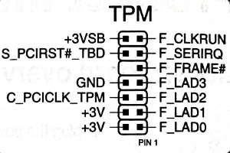](https://www.kencorner.com/wp-content/uploads/2018/03/tpm.jpg)

**(2 ) ATX power connector    (3) CPU socket    (4) CPU and chassis fan connector   (5) DDR4 DIMM slots   (6) Serial ATA connector**

**(7) System Front panel connector**

[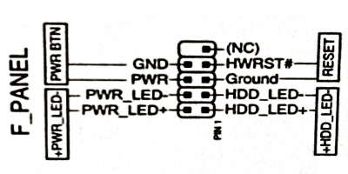](https://www.kencorner.com/wp-content/uploads/2018/03/frontPannel.jpg)

**(8) Chassis instrusion head   (9) Speaker Connector   (10) PCI Express  (11) Clear RTC RAM  (12) Front panel audio connector  (13) Serial port connector  (14) PCI Express slots  (15) LPT connector  (16) USB 3.0 connector  (17) USB 2.0 connector**

# ****Installing components of motherboard****

[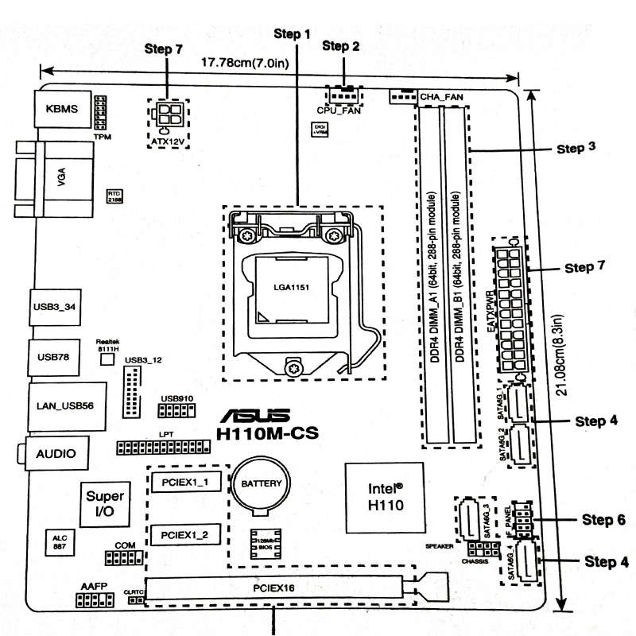](https://www.kencorner.com/wp-content/uploads/2018/03/Steps-in-Installing-motherboard.jpg)

### Step 1 ) Install CPU

[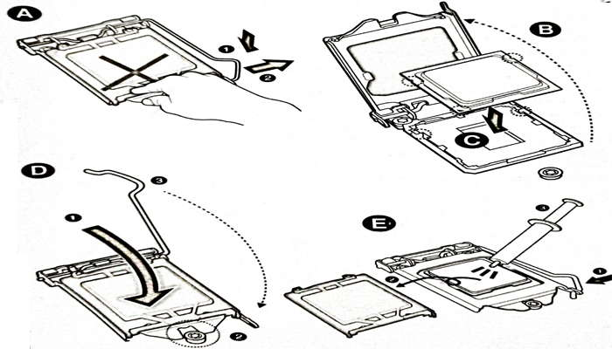](https://www.kencorner.com/wp-content/uploads/2018/03/Step-installing-Cpu.jpg)

### Step 2 ) Installing CPU Fan

[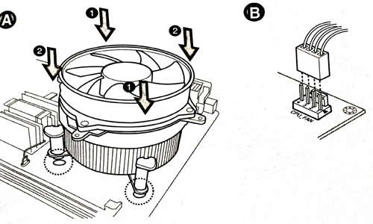](https://www.kencorner.com/wp-content/uploads/2018/03/Installing-cpu-fan.jpg)

### Step 3 ) Install RAM

[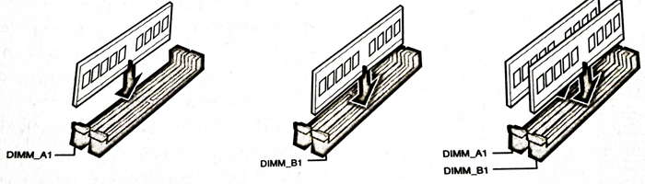](https://www.kencorner.com/wp-content/uploads/2018/03/installing-RAM.jpg)

### Step 4 ) Install SATA devices

### Step 5 ) Install Expansion cards

### Step 6 ) Install system panel connector

### Step 7 ) Install ATX power connector

[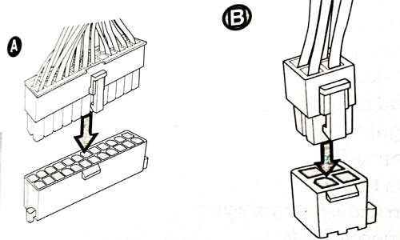](https://www.kencorner.com/wp-content/uploads/2018/03/power-connection-mothereboard.jpg)

### Step 8 ) Connecting input/output devices

### Step 9 ) Power On the system and install Op

**The Computer Chip-sets**

A [chipset](https://en.wikipedia.org/wiki/Chipset#:~:text=In%20a%20computer%20system%2C%20a,usually%20found%20on%20the%20motherboard.) is a group of small circuits that coordinate the flow of data to and from a PC's key components. These key components include the CPU itself, the main memory, the secondary cache, and any devices situated on the buses.

A chipset also controls data flow to and from hard disks and other devices connected to the IDE channels.

A computer has got two main chipsets:

* The NorthBridge (also called the memory controller) is in charge of controlling transfers between the processor and the RAM, which is why it is located physically near the processor. It is sometimes called the GMCH, for Graphic and Memory Controller Hub.
* The SouthBridge (also called the input/output controller or expansion controller) handles communications between slower peripheral devices. It is also called the ICH (I/O Controller Hub). The term "bridge" is generally used to designate a component which connects two buses.

Chipset manufacturers include SIS, VIA, ALI, and OPTI.

**The CPU Clock**

The CPU clock synchronizes the operation of all parts of the PC and provides the basic timing signal for the CPU. Using a quartz crystal, the CPU clock breathes life into the microprocessor by feeding it a constant flow of pulses.

For example, a 200 MHz CPU receives 200 million pulses per second from the clock. A 2 GHz CPU gets two billion pulses per second. Similarly, in any communications device, a clock may be used to synchronize the data pulses between sender and receiver.  
  
A "real-time clock," also called the "system clock," keeps track of the time of day and makes this data available to the software. A "time-sharing clock" interrupts the CPU at regular intervals and allows the operating system to divide its time between active users and/or applications.

**The Complimentary Metal Oxide Semiconductor Random Access Memory (CMOS RAM) CMOS Battery**

Motherboards also include a small separate block of memory made from CMOS RAM chips which are kept alive by a battery (known as a CMOS battery) even when the PC’s power is off. This prevents reconfiguration when the PC is powered on.

CMOS devices require very little power to operate.

The CMOS RAM is used to store basic information about the PC’s configuration for instance:-

* Floppy disk and hard disk drive types
* Information about CPU
* RAM size
* Date and time
* Serial and parallel port information
* Plug and Play information
* Power Saving settings

Other Important data kept in CMOS memory is the time and date, which is updated by a Real-Time Clock (RTC).

# COMPUTER SOFTWATE

# Installation of Soft wares. (computer programs)

**Installation** (or **setup**) of a [computer program](https://en.wikipedia.org/wiki/Computer_program) (including [device drivers](https://en.wikipedia.org/wiki/Device_driver) and [plugins](https://en.wikipedia.org/wiki/Plug-in_(computing))), is the act of making the program ready for [execution](https://en.wikipedia.org/wiki/Execution_(computing)). Installation refers to the particular configuration of a software or hardware with a view to making it usable with the computer. A soft or digital copy of the piece of software (program) is needed to install it.

Common operations performed during software installations include:

* Making sure that necessary [system requirements](https://en.wikipedia.org/wiki/System_requirements) are met
* Checking for existing versions of the software
* Creating or updating program [files](https://en.wikipedia.org/wiki/Computer_file) and folders
* Adding configuration data such as [configuration files](https://en.wikipedia.org/wiki/Configuration_file), [Windows registry](https://en.wikipedia.org/wiki/Windows_registry) entries or [environment variables](https://en.wikipedia.org/wiki/Environment_variable)
* Making the software accessible to the user, for instance by creating [links, shortcuts](https://en.wikipedia.org/wiki/Computer_shortcut) or [bookmarks](https://en.wikipedia.org/wiki/Bookmark_(world_wide_web))
* Configuring components that run automatically, such as [daemons](https://en.wikipedia.org/wiki/Daemon_(computing)) or [Windows services](https://en.wikipedia.org/wiki/Windows_service)
* Performing [product activation](https://en.wikipedia.org/wiki/Product_activation)
* Updating the software versions

## Types of installation approaches

### Attended installation

On [Windows](https://en.wikipedia.org/wiki/Windows) systems, this is the most common form of installation. An installation process usually needs a user who attends it to make choices, such as accepting or declining an [end-user license agreement](https://en.wikipedia.org/wiki/End-user_license_agreement) (EULA), specifying preferences such as the installation location, supplying passwords or assisting in [product activation](https://en.wikipedia.org/wiki/Product_activation). In graphical environments, installers that offer a [wizard-based interface](https://en.wikipedia.org/wiki/Wizard_(software)) are common. Attended installers may ask users to help mitigate the errors. For instance, if the disk in which the computer program is being installed was full, the installer may ask the user to specify another target path or clear enough space in the disk. A common misconception is unarchivation, which is not considered an installation action because it does not include user choices, such as accepting or declining EULA.

### Silent installation

Installation that does not display messages or windows during its progress. "Silent installation" is not the same as "unattended installation" (see below): All silent installations are unattended but not all unattended installations are silent. The reason behind a silent installation may be convenience or subterfuge. [Malware](https://en.wikipedia.org/wiki/Malware) is almost always installed silently.[*[citation needed](https://en.wikipedia.org/wiki/Wikipedia:Citation_needed" \o "Wikipedia:Citation needed)*] For normal users silent installation is of not much use , but in bigger organizations where thousands of users work, deploying the applications becomes a typical task and for that reason silent installation is performed so that the application is installed in background without affecting the work of user. Silent parameters can vary from software to software, if a software/application has silent parameters , it can be checked by " <software.exe> /? " or " <software.exe> /help " or " <software.exe> -help ".

### Unattended installation

Installation that is performed without user interaction during its progress or with no user present at all. One of the reasons to use this approach is to automate the installation of a large number of systems. An unattended installation either does not require the user to supply anything or has received all necessary input prior to the start of installation. Such input may be in the form of [command line](https://en.wikipedia.org/wiki/Command_line) [switches](https://en.wikipedia.org/wiki/Switch_(command_line)) or an *answer file*, a file that contains all the necessary parameters. [Windows XP](https://en.wikipedia.org/wiki/Windows_XP) and [most Linux distributions](https://en.wikipedia.org/wiki/List_of_Linux_distributions) are examples of operating systems that can be installed with an answer file. In unattended installation, it is assumed that there is no user to help mitigate errors. For instance, if the installation medium was faulty, the installer should fail the installation, as there is no user to fix the fault or replace the medium. Unattended installers may record errors in a [computer log](https://en.wikipedia.org/wiki/Computer_data_logging) for later review.

### Headless installation

Installation performed without using a [computer monitor](https://en.wikipedia.org/wiki/Computer_monitor) connected. In attended forms of headless installation, another machine connects to the target machine (for instance, via a [local area network](https://en.wikipedia.org/wiki/Local_area_network)) and takes over the display output. Since a headless installation does not need a user at the location of the target computer, unattended headless installers may be used to install a program on multiple machines at the same time.

### Scheduled or automated installation

An installation process that runs on a preset time or when a predefined condition transpires, as opposed to an installation process that starts explicitly on a user's command. For instance, a [system administrator](https://en.wikipedia.org/wiki/System_administrator) willing to install a later version of a computer program that is being used can schedule that installation to occur when that program is not running. An operating system may automatically install a device driver for a device that the user connects. (See [plug and play](https://en.wikipedia.org/wiki/Plug_and_play).) Malware may also be installed automatically. For example, the infamous [Conficker](https://en.wikipedia.org/wiki/Conficker) was installed when the user plugged an infected device to their compute

**Memory**

A memory is just like a human brain. It is used to store data and instruction. Computer memory is the storage space in computer where data is to be processed and instructions required for processing are stored.

The memory is divided into large number of small parts. Each part is called a cell. Each location or cell has a unique address which varies from zero to memory size minus one.

For example if computer has 64k words, then this memory unit has 64 \* 1024 = 65536 memory location. The address of these locations varies from 0 to 65535.

Memory is primarily of two types

* **Internal Memory** − cache memory and primary/main memory
* **External Memory** − magnetic disk / optical disk etc.

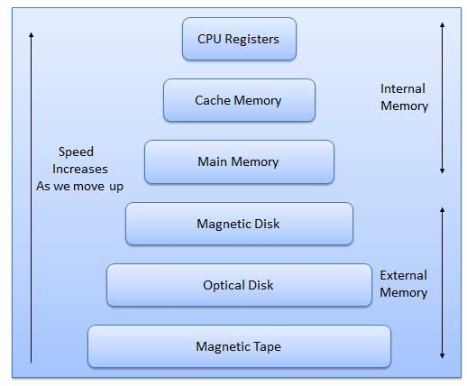

Characteristics of Memory Hierarchy are following when we go from top to bottom.

* Capacity in terms of storage increases.
* Cost per bit of storage decreases.
* Frequency of access of the memory by the CPU decreases.
* Access time by the CPU increases.

**RAM**

A RAM constitutes the internal memory of the CPU for storing data, program and program result. It is read/write memory. It is called random access memory (RAM).

Since access time in RAM is independent of the address to the word that is, each storage location inside the memory is as easy to reach as other location & takes the same amount of time. We can reach into the memory at random & extremely fast but can also be quite expensive.

RAM is volatile, i.e. data stored in it is lost when we switch off the computer or if there is a power failure. Hence, a backup uninterruptible power system (UPS) is often used with computers. RAM is small, both in terms of its physical size and in the amount of data it can hold.

RAM is of two types

* Static RAM (SRAM)
* Dynamic RAM (DRAM)

**Static RAM (SRAM)**

The word **static** indicates that the memory retains its contents as long as power remains applied. However, data is lost when the power gets down due to volatile nature. SRAM chips use a matrix of 6-transistors and no capacitors. Transistors do not require power to prevent leakage, so SRAM need not have to be refreshed on a regular basis.

Because of the extra space in the matrix, SRAM uses more chips than DRAM for the same amount of storage space, thus making the manufacturing costs higher.

Static RAM is used as cache memory needs to be very fast and small.

**Dynamic RAM (DRAM)**

DRAM, unlike SRAM, must be continually **refreshed** in order for it to maintain the data. This is done by placing the memory on a refresh circuit that rewrites the data several hundred times per second. DRAM is used for most system memory because it is cheap and small. All DRAMs are made up of memory cells. These cells are composed of one capacitor and one transistor.

**ROM**

ROM stands for Read Only Memory. The memory from which we can only read but cannot write on it. This type of memory is non-volatile. The information is stored permanently in such memories during manufacture.

A ROM, stores such instruction as are required to start computer when electricity is first turned on, this operation is referred to as bootstrap. ROM chip are not only used in the computer but also in other electronic items like washing machine and microwave oven.

Following are the various types of ROM −

**MROM (Masked ROM)**

The very first ROMs were hard-wired devices that contained a pre-programmed set of data or instructions. These kind of ROMs are known as masked ROMs. It is inexpensive ROM.

**PROM (Programmable Read Only Memory)**

PROM is read-only memory that can be modified only once by a user. The user buys a blank PROM and enters the desired contents using a PROM programmer. Inside the PROM chip there are small fuses which are burnt open during programming. It can be programmed only once and is not erasable.

**EPROM (Erasable and Programmable Read Only Memory)**

The EPROM can be erased by exposing it to ultra-violet light for a duration of upto 40 minutes. Usually, an EPROM eraser achieves this function. During programming an electrical charge is trapped in an insulated gate region. The charge is retained for more than ten years because the charge has no leakage path. For erasing this charge, ultra-violet light is passed through a quartz crystal window (lid). This exposure to ultra-violet light dissipates the charge. During normal use the quartz lid is sealed with a sticker.

**EEPROM (Electrically Erasable and Programmable Read Only Memory)**

The EEPROM is programmed and erased electrically. It can be erased and reprogrammed about ten thousand times. Both erasing and programming take about 4 to 10 ms (millisecond). In EEPROM, any location can be selectively erased and programmed. EEPROMs can be erased one byte at a time, rather than erasing the entire chip. Hence, the process of re-programming is flexible but slow.

**Serial Access Memory**

Sequential access means the system must search the storage device from the beginning of the memory address until it finds the required piece of data. Memory device which supports such access is called a Sequential Access Memory or Serial Access Memory. Magnetic tape is an example of serial access memory.

**Direct Access Memory**

Direct access memory or Random Access Memory, refers to conditions in which a system can go directly to the information that the user wants. Memory device which supports such access is called a Direct Access Memory. Magnetic disks, optical disks are examples of direct access memory.

**Cache Memory**

Cache memory is a very high speed semiconductor memory which can speed up CPU. It acts as a buffer between the CPU and main memory. It is used to hold those parts of data and program which are most frequently used by CPU. The parts of data and programs, are transferred from disk to cache memory by operating system, from where CPU can access them.

**Advantages**

* Cache memory is faster than main memory.
* It consumes less access time as compared to main memory.
* It stores the program that can be executed within a short period of time.
* It stores data for temporary use.

**Disadvantages**

* Cache memory has limited capacity.
* It is very expensive.

Virtual memory is a technique that allows the execution of processes which are not completely available in memory. The main visible advantage of this scheme is that programs can be larger than physical memory. Virtual memory is the separation of user logical memory from physical memory.

This separation allows an extremely large virtual memory to be provided for programmers when only a smaller physical memory is available. Following are the situations, when entire program is not required to be loaded fully in main memory.

* User written error handling routines are used only when an error occurred in the data or computation.
* Certain options and features of a program may be used rarely.
* Many tables are assigned a fixed amount of address space even though only a small amount of the table is actually used.
* The ability to execute a program that is only partially in memory would counter many benefits.
* Less number of I/O would be needed to load or swap each user program into memory.
* A program would no longer be constrained by the amount of physical memory that is available.
* Each user program could take less physical memory, more programs could be run the same time, with a corresponding increase in CPU utilization and throughput.

**Auxiliary Memory**

Auxiliary memory is much larger in size than main memory but is slower. It normally stores system programs, instruction and data files. It is also known as secondary memory. It can also be used as an overflow/virtual memory in case the main memory capacity has been exceeded. Secondary memories cannot be accessed directly by a processor. First the data/information of auxiliary memory is transferred to the main memory and then that information can be accessed by the CPU. Characteristics of Auxiliary Memory are following −

* **Non-volatile memory** − Data is not lost when power is cut off.
* **Reusable** − The data stays in the secondary storage on permanent basis until it is not overwritten or deleted by the user.
* **Reliable** − Data in secondary storage is safe because of high physical stability of secondary storage device.
* **Convenience** − With the help of a computer software, authorised people can locate and access the data quickly.
* **Capacity** − Secondary storage can store large volumes of data in sets of multiple disks.
* **Cost** − It is much lesser expensive to store data on a tape or disk than primary memory.

**LAN (Local Area Network) – Topology, Types, Applications, Advantage**

Network which is devised to operate over a limited geographical area is referred as LAN or Local Area Network. This post will discuss in detail about what is LAN (Local Area Network), how it works, its topology, types, applications, advantages and disadvantages.

**What is LAN (Local Area Network )**

LAN is basically a [Data Communication](https://electricalfundablog.com/digital-communication-introduction-basic-components-how-signal-process-works-and-advantages/) Network. In this type of Network, several computers and their peripherals like disc storage devices, printers are connected to a single high speed data line within a limited area. Local Area Network is usually a privately owned network. In LAN, data is divided and transmitted in the form of packets and regenerated back by the receiving computer.

It provides high data rates extending from 10-100 Mbps and up. Latest LAN’s can provide data rate up to 10 Gbps. The coverage area is less than 10 kms. Like any other Networks, LAN also requires Hardware and Software components. Hardware consists of transmission medium and connecting devices like Transceivers, Bridges, Switches, Repeaters etc. Software has Application Programs which includes protocols defined by IEEE Standard. Fig. 2 shows schematic diagram of Ethernet LAN.

**Types of Local Area Network (LAN)**

LAN’s can be implemented using:

* Ethernet LAN (Wired connection)
* WLAN (Wireless)

**Ethernet LAN (Wired connection)**

Ethernet LAN uses Ethernet cables to connect the devices in a network. In this type of connection, the network installation is wired and the Switches and Routers are configured using the network settings. Standard [Internet Protocol](https://electricalfundablog.com/communication-protocols-embedded-systems/) is set, that allows the internet to run on different devices within the network.

**WLAN (Wireless Local Area Network)**

WLAN uses Radio waves as the means of [communication](https://electricalfundablog.com/digital-communication-introduction-basic-components-how-signal-process-works-and-advantages/). It does not require cables to connect the devices. The advantage of WLAN over LAN is the increased security it offers. The users can access the internet without wired connection (wireless) if they are within the range of the [Router](https://electricalfundablog.com/router-works-types/). With the help of WLAN connection, many devices can be connected simultaneously, provided they all are within the range of the [Router](https://electricalfundablog.com/router-works-types/).

**LAN (Local Area Network) Topology**

Topology is defined as the pattern of interconnection between the nodes of the network. The three basic topologies of LAN are:

* Star Topology
* Ring Topology
* Bus Topology

**Star Topology**

In this network, all the nodes are connected to Central Node. The devices are not connected to each other and transmits the messages to the Central Node. The central node is responsible for transmitting the message to the required destination. It is the most widely used topology for LAN’s.

**Ring Topology**

In this network, the nodes are interconnected to make a closed loop. Each node communicates with the nodes on its either side with the help of Token (information passing). The nodes with Token are allowed to transmit data. This topology eliminates the connection of nodes with the central node i.e. there is no need of Network Server to control other devices.

**Bus Topology**

In this network, all the nodes including computers and servers are connected to a single cable termed as Bus. This network is easier compared to other networks and is economical. Source node transmits a signal which is broadcast to all the other nodes via Bus cable. Though the message is broadcast, the intended recipient receives the signal. The recipient can accept the signal if its MAC Address or IP Address matches and data transmission occurs in a single direction.

**Fig. 5 – (a) Star Topology (b) Ring Topology (c) Bus Topology**

**How does LAN (Local Area Network) Work**

To understand how LAN works, consider Fig. 6, which shows the 7- Layers of [OSI Model](https://electricalfundablog.com/osi-model/). It is necessary to know the three lower levels of [OSI Model](https://electricalfundablog.com/osi-model/) i.e.

* Physical Layer
* Data Link Layer
* Network Layer

**Physical Layer**

The Physical Layer transmits raw data bits over communication lines. It deals with establishing physical circuit between devices. Physical Layer [protocols](https://electricalfundablog.com/communication-protocols-embedded-systems/) and standards are responsible for type of modulation to be used for transmitting digital data over analog transmission lines. It accounts for the components of network like Multiplexers, Repeaters, Modems etc.

**Data Link Layer**

The Data Link Layer is responsible for transferring data over the communication channel provided by the Physical Layer. This layer breaks the data into data frames, transmits the frames sequentially over the channel. Error detection and correction is done and the data is transmitted to Network Layer.

**Network Layer**

The Network Layer helps in routing the data across the network from source node to receiving node. This Layer provides interface between a host and the network. Based on Topology used, routing of packets takes place to the receiving device where the conversion of data occurs and

**Applications of LAN (Local Area Network)**

The applications include:

* LAN is used for school environment, offices, hospitals etc as it allows sharing of resources like sharing data, scanners, printing and internet.
* LAN serves users at home to access internet.
* LAN’s are widely used in manufacturing industries where a central server coordinates the activities of other machines.
* High speed LANs are typically used to connect many slower networks together.

**Advantages of LAN (Local Area Network)**

The advantages of LAN are:

* Provides high-bandwidth communication.
* Transmission medium is inexpensive.
* Bandwidth is utilized effectively.
* Maintenance is easy.

**Disadvantages of LAN (Local Area Network)**

The disadvantages of LAN are:

* Speed reduces as it includes sharing of resources.
* Less Secure.
* Requires skilled technicians to setup the network.
* Covers Limited area.

**E-waste and management**

What is e-waste? And [how do we dispose of it](http://www.ewaste1.com/how-to-properly-recycle-electronics/)?

E-waste is electronic products that are unwanted, not working, and nearing or at the end of their “useful life.” Computers, televisions, VCRs, stereos, copiers, and fax machines are everyday electronic products.

The ongoing challenge of how best to dispose of used and unwanted electronics isn’t a new one and dates back at least to the 1970s. But a lot has changed since then, particularly the number of electronics being discarded today.

We also have something else today: a term for this issue. After several terms got suggested, including “Digital rubbish,” a consensus formed around the simple word “e-waste.”

Generations

## ****Causes of E-Waste****

The main causes of Electronic Waste are:

* Advancement in Technology.
* Changes in style fashion and status.
* End of their helpful life.
* Not taking precautions while handling them.

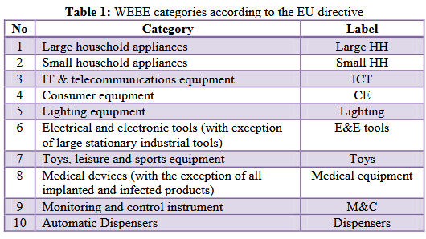

**The Dangers of E-waste**

According to the World Health Organization (WHO), health risks may result from

1. Direct contact with toxic materials that leach from e-waste. These include minerals such as lead, cadmium, chromium, brominated flame retardants, or polychlorinated biphenyls (PCBs). Danger can come from inhalation of the toxic fumes, as well as from the accumulation of chemicals in soil, water, and food.
2. Land and sea animals as well. In developing countries, the risks are exceptionally high because some developed countries send their e-waste there. Studies have shown this global e-waste has detrimental effects on the people that work with the e-waste but also the people that live around it.
3. For an expectant mother, exposure to toxic e-waste can affect the health and development of her unborn child for the rest of its life. Potential adverse health effects include negative birth outcomes, such as stillbirth and premature births, as well as low birth weight and length.
4. The Negative Effects on Soil.When improper disposal of e-waste in regular landfills or in places where it is dumped illegally, both heavy metals and flame retardants can seep directly from the e-waste into the soil, causing contamination of underlying groundwater or contamination of crops that may be planted near by or in the area in the future. When the soil is contaminated by heavy metals, the crops become vulnerable to absorbing these toxins, which can cause many illnesses and doesn’t allow the farmland to be as productive as possible.
5. The Negative Effects on Water

After soil contamination, heavy metals from e-waste, such as mercury, lithium, lead and barium, then leak through the earth even further to reach groundwater. When these heavy metals reach groundwater, they eventually make their way into ponds, streams, rivers and lakes. Through these pathways, acidification and toxification are created in the water, which is unsafe for animals, plants and communities even if they are miles away from a recycling site. Clean drinking water becomes problematic to find.

Because of this, a proper recycling process needs to be put in place to protect us and future

Challenges Facing E-waste Management in Kenya

The greatest challenges facing developing countries in  
the management of WEEE include:

Lack of legislation andappropriate infrastructure for e-waste management,  
Absence of frameworks for end-of-life (EoL) product take-  
back

Implementation of extended producer  
responsibility (EPR

low-level of citizen  
awareness on the harmful effects of WEEE

**Collection, Treatment and Disposal System**

Various methods of treatment and disposal system includes:

* **Land Filling**– Disposal of Electronic Waste is mainly through land filling. Mostly, the discarded electronic goods finally end-up in landfill sites along with other municipal waste or are openly burnt releasing toxic and carcinogenic substances into the atmosphere.
* **Incineration**– In this complete combustion process, the waste material is burned in specially designed incinerators at a high temperature (900-1000o C). It reduces waste volume and some environmentally hazardous organic substances are converted into less hazardous compounds.
* **Recycling of E-Waste** – Recycling involves dismantling, processing and end processing. Comparatively, the value of recycling from the element could be much higher in comparison to other treatments.
* **Re-use**– It includes direct second hand use or use after slight modifications to the original functioning equipment like Inkjet cartridge is used after refilling. Old working computers can be donated to schools or organization working in the field of education. Computers beyond repairs can be returned back to the manufacturers. This can considerably reduce the volume of E-Waste generation converted into less hazardous compounds.

**Conclusion**

Recycling of E-Waste is necessary but it should be conducted in a safe and standardized manor. The dangerous nature of Electronic Waste is one of the fastest growing environment problems of the world. Lack of awareness and appropriate skills increases amount of Electronic Waste. Necessary information should be provided to these workers for safe handling of E-Waste and personal protection.

* **What is a File System?**
* A file system is a process of managing how and where data on a storage disk, which is also referred to as file management or FS. It is a logical disk component that compresses files separated into groups, which is known as directories. It is abstract to a human user and related to a computer; hence, it manages a disk's internal operations. Files and additional directories can be in the directories. Although there are various file systems with Windows, NTFS is the most common in modern times. It would be impossible for a file with the same name to exist and also impossible to remove installed programs and recover specific files without file management, as well as files would have no organization without a file structure. The file system enables you to view a file in the current directory as files are often managed in a hierarchy.
* 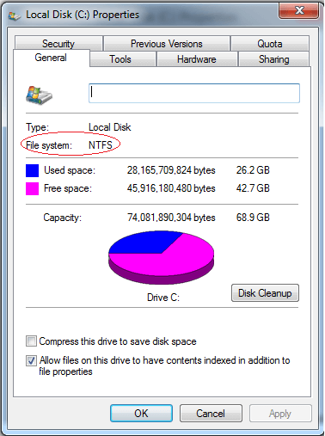
* A disk (e.g., Hard disk drive) has a file system, despite type and usage. Also, it contains information about file size, file name, file location fragment information, and where disk data is stored and also describes how a user or application may access the data. The operations like metadata, file naming, storage management, and directories/folders are all managed by the file system.
* On a storage device, files are stored in sectors in which data is stored in groups of sectors called blocks. The size and location of the files are identified by the file system, and it also helps to recognize which sectors are ready to be used. Other than Windows, there are some other operating systems that contain FAT and NTFS file system. But Apple product (like iOS and macOS) uses HFS+ as operating system is horizon by many different kinds of file systems.
* Sometimes the term "file system" is used in the reference of partitions. For instance, saying, "on the hard drive, two files systems are available," that does not have to mean the drive is divided between two file systems, NTFS and FAT. But it means two separate partitions are there that use the same physical disk.
* In order to work, a file system is required by most of the applications you come into contact with; therefore, each partition should have one. Furthermore, if a program is built for use in macOS, you will be unable to use this program on windows because programs are file system-dependent.
* **Examples of file systems**
* The examples of file systems are given below:
* **FAT:** FAT is a type of file system, which is developed for hard drives. It stands for file allocation table and was first introduced in 1977, which is used for 12 or 16 bits for each and every cluster access into the file allocation table (FAT). On hard drives and other computer systems, it helps to manage files on Microsoft operating systems. In devices like digital cameras, flash memory, and other portable devices, it is also often found that is used to store file information. It also helps to extend the life of a hard drive as it minimizes the wear and tears on the hard disc. Today, FAT is not used by later versions of Microsoft Windows like Windows XP, Vista, 7, and 10 as they use NTFS. The **FAT8, FAT12, FAT32, FAT16** are all the different types of FAT (for file allocation table).
* **GFS:** A GFS is a file system, which stands for Global File System. It has the ability to make enable multiple computers to act as an integrated machine, which is first developed at the University of Minnesota. But now it is maintained by Red Hat. When the physical distance of two or more computers is high, and they are unable to send files directly with each other, a GFS file system makes them capable of sharing a group of files directly. A computer can organize its I/O to preserve file systems with the help of a global file system.
* **HFS:** HFS (Hierarchical file system) is the file system that is used on a Macintosh computer for creating a directory at the time a hard disk is formatted. Generally, its basic function is to organize or hold the files on a Macintosh hard disk. Apple is not capable of supporting to write to or format HFS disks since when OS X came on the market. Also, HFS-formatted drives are not recognized by Windows computers as HFS is a Macintosh format. With the help of WIN32 or NTFS file systems, Windows hard drives are formatted.
* **NTFS:** NTFS is the file system, which stands for NT file system and stores and retrieves files on Windows NT operating system and other versions of Windows like Windows 2000, Windows XP, Windows 7, and Windows 10. Sometimes, it is known as the New Technology File System. As compared to the FAT and HPFS file system, it provides better methods of file recovery and data protection and offers a number of improvements in terms of extendibility, security, and performance.
* **UDF:** A UDF is a file system, stands for Universal Disk Format and used first developed by OSTA (Optical Storage Technology Association) in 1995 for ensuring consistency among data written to several optical media. It is used with CD-ROMs and DVD-ROMs and is supported on all operating systems. Now, it is used in the process of CD-R's and CD-RW's, called packet writing.

## Hardware and Software Trends You Can't Miss

1. [Hardware Trends You Can't Miss](https://studybay.com/blog/trends-in-computer-hardware-and-software-platforms/#0)
   1. [Laptops Above All](https://studybay.com/blog/trends-in-computer-hardware-and-software-platforms/#0_0)
   2. [5G Coverage and High-Speed Connectivity](https://studybay.com/blog/trends-in-computer-hardware-and-software-platforms/#0_1)
   3. [Virtual Reality Headsets](https://studybay.com/blog/trends-in-computer-hardware-and-software-platforms/#0_2)
   4. [New Internet of Things Solutions](https://studybay.com/blog/trends-in-computer-hardware-and-software-platforms/#0_3)
2. [Major Software Trends For 2022](https://studybay.com/blog/trends-in-computer-hardware-and-software-platforms/#1)
   1. [Cloud Computing Everywhere](https://studybay.com/blog/trends-in-computer-hardware-and-software-platforms/#1_0)
   2. [Cybersecurity Is a Top Priority](https://studybay.com/blog/trends-in-computer-hardware-and-software-platforms/#1_1)
   3. [Rise of Artificial Intelligence](https://studybay.com/blog/trends-in-computer-hardware-and-software-platforms/#1_2)
   4. [Progressive Web Applications Are the Next Big Thing](https://studybay.com/blog/trends-in-computer-hardware-and-software-platforms/#1_3)
   5. [Java Is Still a Hit but Python Steps on the Heels](https://studybay.com/blog/trends-in-computer-hardware-and-software-platforms/#1_4)

With everything that happened the previous year, is it easy to speak about cut edge technologies and current trends? Actually, it is definitely the thing that we should do because the year of social distancing in the real world has revealed the importance of being close in virtual reality. So, what are computer hardware and software trends that will have the power in 2022?

## Hardware Trends You Can't Miss

Though 2022 sounds a bit frightening, and we really don't know what to expect of the upcoming year, it is possible to predict that the real-time situation may be somewhat inspiring.

### Laptops Above All

Laptops are not the new word in the computer industry, and their products used to have a very stable tendency for years. However, it was 2020 that showed that some companies like Microsoft or Intel were moving in this direction very slowly. The [new generation of mobile computers](https://www.theverge.com/21250695/best-laptops) should have more opportunities, better CPU, and features like flawless camera, good microphone, longer battery life, etc. As a large number of people work from home right now, they need hardware platforms that are oriented on daily usage.

### 5G Coverage and High-Speed Connectivity

It is obvious that Verizon will announce[further expansion of the 5G network](https://www.lightreading.com/ossbss/verizon-lays-out-mmwave-5g-expansion-plans-for-2021/d/d-id/766921), but it is not the only surprise we can expect. It seems that the company is going to work on the Internet of Things and the 5G data transmissions. So, it's only a matter of minutes when we see tablet and laptop companies that will follow this stream and produce mobile devices with this improved type of connection.

### Virtual Reality Headsets

We can expect VR technology to come up some steps closer to the mainstream with [modern models of wireless headsets](https://www.cnet.com/news/the-best-vr-headset-for-2021/)for both consoles and PCs. Demand is big and only getting bigger since humanity is ready to change as never before. Maximillian Diez, the CEO of Twenty Five Ventures — a leader in startup consultancy, believes that the pandemic period is the best time [to incorporate VR](https://www.forbes.com/sites/forbesrealestatecouncil/2021/02/01/virtual-reality-will-be-a-part-of-the-post-pandemic-built-world/?sh=43a5282548de) along with social media and online meetings.

### New Internet of Things Solutions

The time has come for smart IoT solutions that are suitable for personal use. According to a [Business Insider report](https://www.businessinsider.com/internet-of-things-report), we can expect more than 41 billion IoT devices by 2027 compared to 8 billion just 2 years ago. Speaking about 2022, they will surely find their place in the health and safety industry, e.g. with products that detect mask compliance or that elevate body temperature.

## Major Software Trends For 2022

Programmers are still the kings of the world, and new software systems will prove this once again. Standing is not an option, and the only way to get the edge of the competitors these days is to stay at the forefront of current trending technologies.

### Cloud Computing Everywhere

If there were any doubt in terms of cloud adoptions, the previous year has wiped that away. Forrester has predicted that the [cloud information technology market will return to hypergrowth](https://www.forbes.com/sites/forrester/2020/10/22/predictions-2021-cloud-computing-powers-pandemic-recovery/?sh=22b2a3a5aa02) even when most of the industry suffers heavily.

Speaking about cloud trends, it is worth mentioning:

* growth of multi and hybrid cloud environments;
* SaaS solutions that reduce cloud breaches, bottlenecks, or blind spots;
* outsourcing partners focused on data, visibility, IoT, etc.;
* Focus on Artificial Intelligence (AI) and Machine learning (ML).

### Cybersecurity Is a Top Priority

Cloud information systems are not the only place where it is important to take control over blind spots and bottlenecks. With society going online, attacking methods are becoming more and more advanced. So, it is time for companies to develop strong security practices. It can be predicted that the current situation will lead to a big demand for cyber insurance policies. There are already some [cases of companies who have purchased such insurance](https://www.insurancebusinessmag.com/us/news/cyber/more-companies-purchasing-cyber-insurance--marsh-218065.aspx), and the chances are this market will be growing through the next year.

### Rise of Artificial Intelligence

The [McKinsey AI survey](https://www.mckinsey.com/business-functions/mckinsey-analytics/our-insights/global-survey-the-state-of-ai-in-2020) claims that 50% of respondents stated that their companies are already using AI in at least one function. It means there is no sense to wait for a slowdown since AI will become an integral part of our everyday lives very soon.

What can we expect in 2022?

* Development of computer vision apps aimed to monitor public spaces. Data sensors, cameras, and artificial computer systems are even able to monitor social distancing.
* Rise of predictive analysis. Companies need new strategies to expand their influence and find new customers. AI algorithms that become smarter and smarter every day provide businesses with access to sales data and great insights into customers' preferences.
* Growth of neuro-linguistic programming and automated speech recognition.
* Implementation of robotics in manufacturing, marketing, finance, and knowledge process outsourcing industries for business processes automation.

### Progressive Web Applications Are the Next Big Thing

The days when people were ready to wait for applications to be downloaded are gone, and modern society prefers a quick fix. Progressive web apps are much lighter and faster and offer an incredible user experience. They can work offline and[have given 137% in user engagement.](https://customerthink.com/how-progressive-web-apps-claim-to-be-the-future-business/)From the software development side, PWAs are low-cost and time-saving. Such leaders as [Pinterest, Forbes, Starbucks](https://www.outsystems.com/blog/posts/pwa-examples/?utm_source=google&utm_medium=cpc&utm_campaign=Awareness_G_GBL_Search&utm_term=%2Bprogressive%20%2Bweb%20%2Bapplications&utm_content=awareness&gclid=CjwKCAjw6qqDBhB-EiwACBs6x0Rf3tvflxv8KHmW3Fe8lCvtEJ9cFhGbWEKJUAzNftO6pDI9oWlxLxoCh3kQAvD_BwE" \t "_blank), etc., have already been using this technology and report to have experienced huge increases in their add revenue rate and time their users spend on their apps.

### Java Is Still a Hit but Python Steps on the Heels

Since the Java programming language appeared in the mid-'90s, it has reached the dominating position. These days it has been adopted by a large number of behemoths like Microsoft, Amazon, Google, etc. Due to its high performance and security level, Java remains one of the software trends in 2022. However, it has much more to offer:

* incredible stability;
* automatic memory allocation;
* wide use in mobile devices running on Android operating system;
* wide range of open-source software libraries.

The interesting fact is that Python is catching up. It tops the list of languages that grow extremely fast, and we can expect great success in the long run.

These large-scale trends are going to change not the future but the present. We are witnessing something incredible, and the choice of whether you want to be part of these incredible changes is up to you!

## [What is a Progressive Web App?](https://developer.mozilla.org/en-US/docs/Web/Progressive_web_apps/Introduction#what_is_a_progressive_web_app)

**Note:** The term "Progressive Web App" isn't a formal or official name. It's just a shorthand used initially by Google for the concept of creating a flexible, adaptable app using only web technologies.

PWAs are web apps developed using a number of specific technologies and standard patterns to allow them to take advantage of both web and native app features. For example, web apps are more discoverable than native apps; it's a lot easier and faster to visit a website than to install an application, and you can also share web apps by sending a link.

On the other hand, native apps are better integrated with the operating system and therefore offer a more seamless experience for the users. You can install a native app so that it works offline, and users love tapping their icons to easily access their favorite apps, rather than navigating to it using a browser.

PWAs give us the ability to create web apps that can enjoy these same advantages.

It's not a brand new concept—such ideas have been revisited many times on the web platform with various approaches in the past. Progressive Enhancement and responsive design already allow us to build mobile friendly websites.

PWAs, however, provide all this and more without losing any of the existing features that make the web great.

## [What makes an app a PWA?](https://developer.mozilla.org/en-US/docs/Web/Progressive_web_apps/Introduction#what_makes_an_app_a_pwa)

As we hinted at above, PWAs are not created with a single technology. They represent a new philosophy for building web apps, involving some specific patterns, APIs, and other features. It's not that obvious if a web app is a PWA or not from first glance. An app could be considered a PWA when it meets certain requirements, or implements a set of given features: works offline, is installable, is easy to synchronize, can send push notifications, etc.

In addition, there are tools to measure how complete (as a percentage) a web app is, such as [Lighthouse](https://developer.chrome.com/docs/lighthouse/overview/). By implementing various technological advantages, we can make an app more progressive, thus ending up with a higher Lighthouse score. But this is only a rough indicator.

There are some key principles a web app should try to observe to be identified as a PWA. It should be:

* [Discoverable](https://developer.mozilla.org/en-US/docs/Web/Progressive_web_apps/Introduction#discoverability), so the contents can be found through search engines.
* [Installable](https://developer.mozilla.org/en-US/docs/Web/Progressive_web_apps/Introduction#installability), so it can be available on the device's home screen or app launcher.
* [Linkable](https://developer.mozilla.org/en-US/docs/Web/Progressive_web_apps/Introduction#linkability), so you can share it by sending a URL.
* [Network independent](https://developer.mozilla.org/en-US/docs/Web/Progressive_web_apps/Introduction#network_independence), so it works offline or with a poor network connection.
* [Progressively enhanced](https://developer.mozilla.org/en-US/docs/Web/Progressive_web_apps/Introduction#progressive_enhancement_support), so it's still usable on a basic level on older browsers, but fully-functional on the latest ones.
* [Re-engageable](https://developer.mozilla.org/en-US/docs/Web/Progressive_web_apps/Introduction#re-engageability), so it's able to send notifications whenever there's new content available.
* [Responsively designed](https://developer.mozilla.org/en-US/docs/Web/Progressive_web_apps/Introduction#responsiveness), so it's usable on any device with a screen and a browser—mobile phones, tablets, laptops, TVs, refrigerators, etc.
* [Secure](https://developer.mozilla.org/en-US/docs/Web/Progressive_web_apps/Introduction#secure), so the connections between the user, the app, and your server are secured against any third parties trying to get access to sensitive data.

Offering these features and making use of all the [advantages](https://developer.mozilla.org/en-US/docs/Web/Progressive_web_apps/Introduction#advantages_of_web_applications) offered by web applications can create a compelling, highly flexible offering for your users and customers.

### [Is it worth doing all that?](https://developer.mozilla.org/en-US/docs/Web/Progressive_web_apps/Introduction#is_it_worth_doing_all_that)

Absolutely! With a relatively small amount of effort required to implement the core PWA features, the benefits are huge. For example:

* A decrease in loading times after the app has been installed, thanks to caching with [service workers](https://developer.mozilla.org/en-US/docs/Web/API/Service_Worker_API), along with saving precious bandwidth and time. PWAs have near-instantaneous loading (from the second visit).
* The ability to update only the content that has changed when an app update is available. In contrast, with a native app, even the slightest modification can force the user to download the entire application again.
* A look and feel that is more integrated with the native platform—app icons on the home screen or app launcher, applications that automatically run in full screen mode, etc.
* Re-engaging with users through the use of system notifications and push messages, leading to more engaged users and better conversion rates.

It's well worth trying out a PWA approach, so you can see for yourself if it works for your app.

## [Advantages of web applications](https://developer.mozilla.org/en-US/docs/Web/Progressive_web_apps/Introduction#advantages_of_web_applications)

A fully-capable progressive web application should provide all of the following advantages to the user.

### [Discoverability](https://developer.mozilla.org/en-US/docs/Web/Progressive_web_apps/Introduction#discoverability)

The eventual aim is that web apps should have better representation in search engines, be easier to expose, catalog and rank, and have metadata usable by browsers to give them special capabilities.

Some of the capabilities have already been enabled on certain web-based platforms by proprietary technologies like [Open Graph](https://ogp.me/), which provides a format for specifying similar metadata in the [HTML](https://developer.mozilla.org/en-US/docs/Glossary/HTML) [<head>](https://developer.mozilla.org/en-US/docs/Web/HTML/Element/head) block using [<meta>](https://developer.mozilla.org/en-US/docs/Web/HTML/Element/meta) tags.

The relevant web standard here is the [Web app manifest](https://developer.mozilla.org/en-US/docs/Web/Manifest), which defines features of an app such as name, icon, splash screen, and theme colors in a [JSON](https://developer.mozilla.org/en-US/docs/Glossary/JSON)-formatted manifest file. This is for use in contexts such as app listings and device home screens.

### [Installability](https://developer.mozilla.org/en-US/docs/Web/Progressive_web_apps/Introduction#installability)

A core part of the web app experience is for users to have app icons on their home screen, and be able to tap to open apps into their own native container that feels nicely integrated with the underlying platform.

Modern web apps can have this native app feel via properties set inside the Web app manifest, and via a feature available in modern smartphone browsers called [web app installation](https://developer.mozilla.org/en-US/docs/Web/Progressive_web_apps/Installing).

### [Linkability](https://developer.mozilla.org/en-US/docs/Web/Progressive_web_apps/Introduction#linkability)

One of the most powerful features of the web is the ability to link to an app at a specific URL without the need for an app store or complex installation process. This is how it has always been.

### [Network independence](https://developer.mozilla.org/en-US/docs/Web/Progressive_web_apps/Introduction#network_independence)

Modern web apps can work when the network is unreliable, or even non-existent. The basic ideas behind network independence are to be able to:

* Revisit a site and get its contents even if no network is available.
* Browse any kind of content the user has previously visited at least once, even under situations of poor connectivity.
* Control what is shown to the user in situations where there is no connectivity.